

**Appendix 1 – Site Plan**

**19/01774/FUL – Littlemead Business Park**

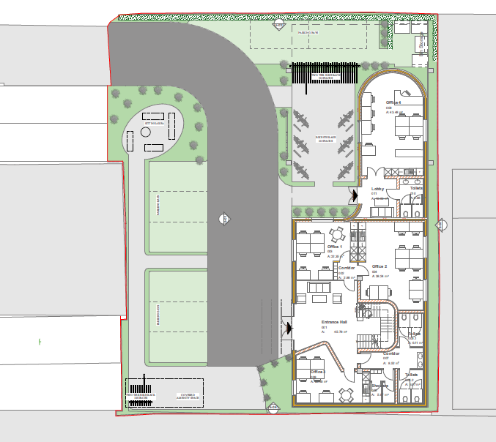

Ferry Hinksey Road